Cisco Packet Tracer Network Configuration Documentation

Task 1: Static IP Configuration with Router, Switch, and 3 PCs
Steps:
- - Create a router and assign a static IP (192.168.1.1/24) to its FastEthernet0/0 interface.
- - Create a switch and connect it to the router.
- - Connect three PCs to the switch.
- - Configure each PC with a static IP and set the router IP as the default gateway.
Example CLI commands on router:
Router> enable
Router# configure terminal
Router(config)# interface FastEthernet0/0
Router(config-if)# ip address 192.168.1.1 255.255.255.0
Router(config-if)# no shutdown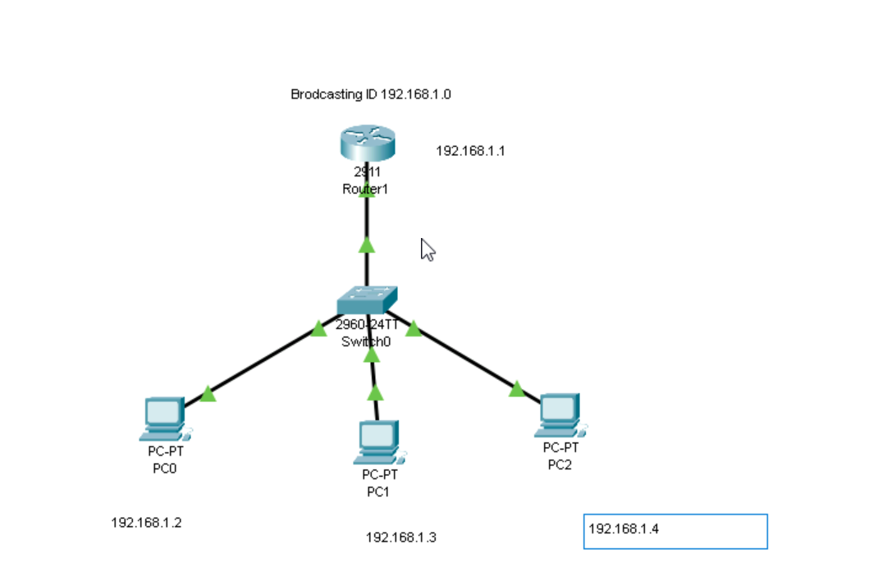

Task 2: Static Network Configuration with Router, Switch, and 3 PCs
Steps:
- - Create a router and assign a static IP.
- - Attach a switch to the router.
- - Connect three PCs to the switch.
- - Configure static IPs on each PC.
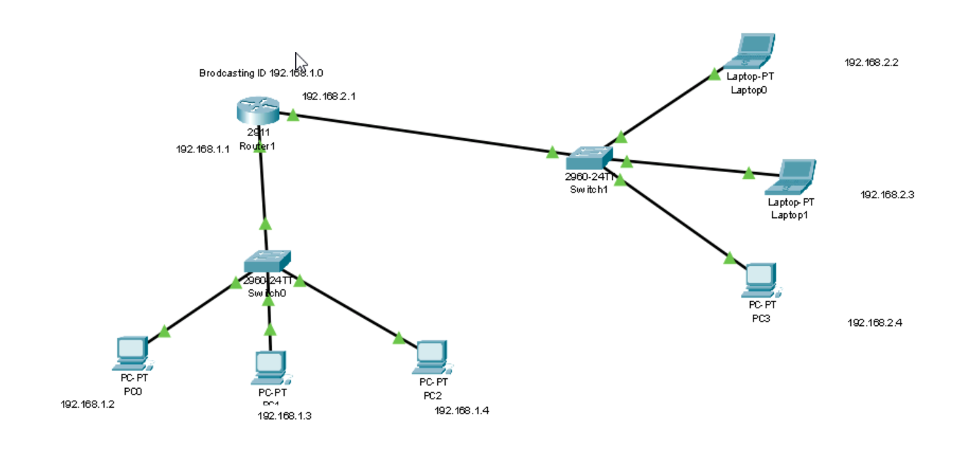

Task 3: Find Network Details Using Command Prompt
Steps:
- - Open Command Prompt on your system.
- - Type the command: ipconfig
- - Note the IPv4 address and subnet mask.
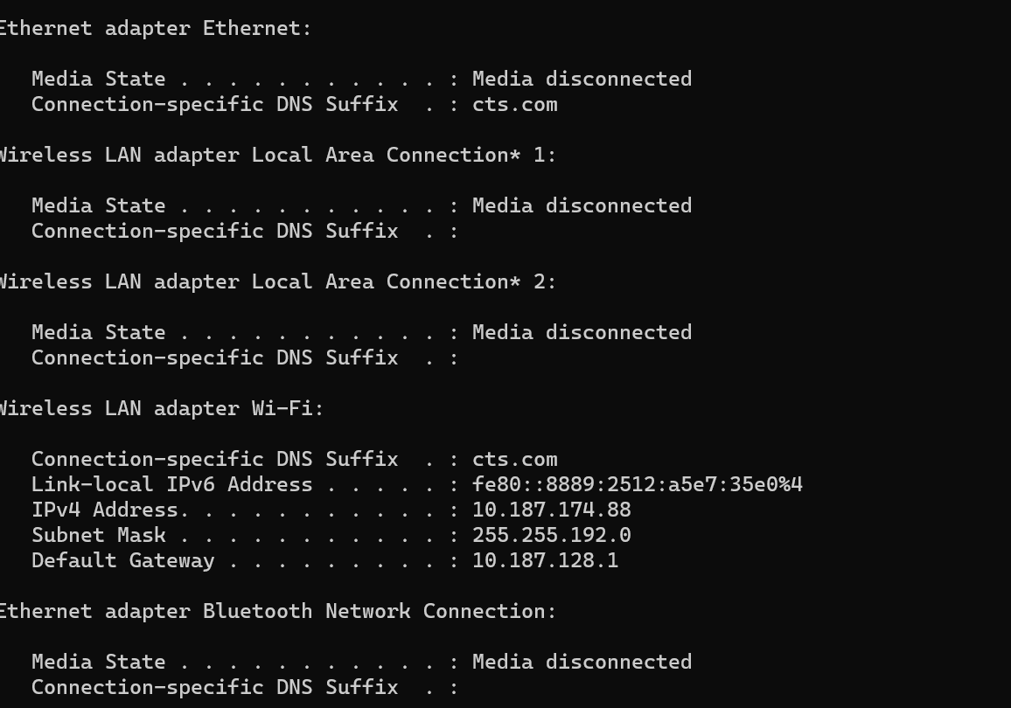

Task 4: DHCP Network Configuration with Router, Switch, Server, and 5 PCs
Steps:
- - Create a router and assign IP to its interface.
- - Attach a switch to the router.
- - Connect a server and five PCs to the switch.
- - Configure the server as a DHCP server.
- - Set PCs to obtain IP automatically.
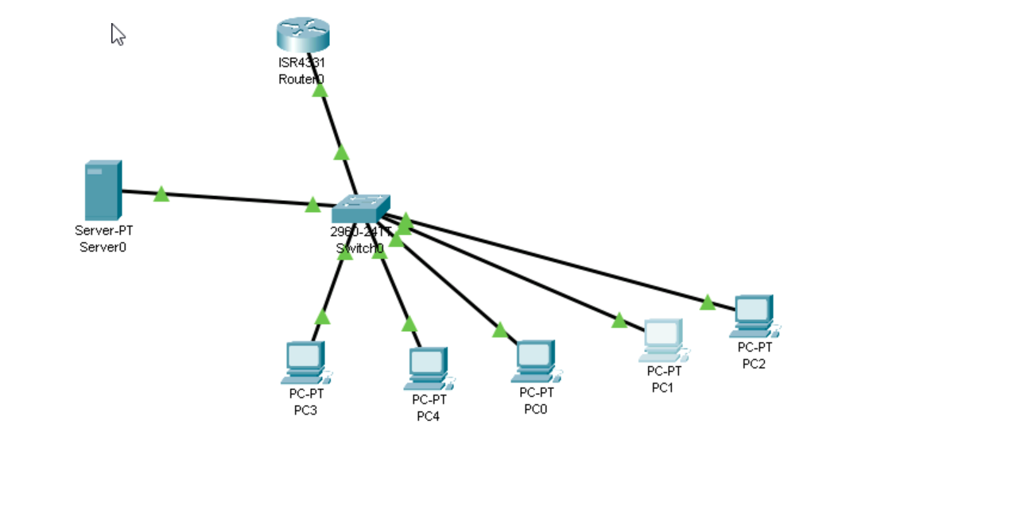

Task 5: VLAN Configuration for HR and DEV Departments
Steps:
- - Create a router and attach a switch.
- - Create two VLANs: VLAN 10 for HR and VLAN 20 for DEV.
- - Assign HR1 and HR2 to VLAN 10, DEV1 and DEV2 to VLAN 20.
- - Configure switch ports for respective VLANs.
- - Ensure HR devices can communicate with each other and DEV devices can communicate with each other.
- - Prevent communication between HR and DEV VLANs.
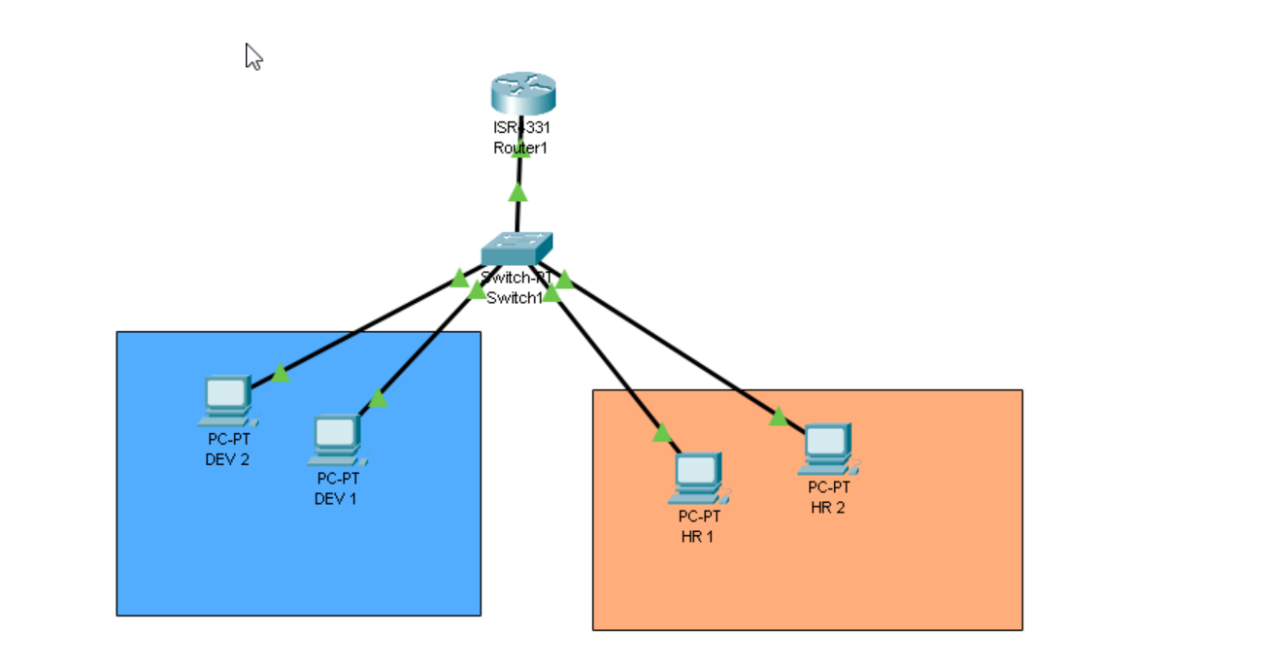
Example CLI commands on switch:
Switch> enable
Switch# configure terminal
Switch(config)# vlan 10
Switch(config-vlan)# name HR
Switch(config)# vlan 20
Switch(config-vlan)# name DEV
Switch(config)# interface FastEthernet0/1
Switch(config-if)# switchport mode access
Switch(config-if)# switchport access vlan 10
Switch(config)# interface FastEthernet0/2
Switch(config-if)# switchport mode access
Switch(config-if)# switchport access vlan 10
Switch(config)# interface FastEthernet0/3
Switch(config-if)# switchport mode access
Switch(config-if)# switchport access vlan 20
Switch(config)# interface FastEthernet0/4
Switch(config-if)# switchport mode access
Switch(config-if)# switchport access vlan 20

